USN | 1 | M | S
M S RAMAIAH INSTITUTE OF TECHNOLOGY
(AUTONOMOUS INSTITUTE, AFFILIATED TO VTU)
BANGALORE – 560 054
SEMESTER END EXAMINATIONS – MAY/JUNE 2016

Course & Branch | : | B.E. – Information Science & Engg. | Semester | : | IV
Subject | : | Design and Analysis of Algorithms | Max. Marks | : | 100
Subject Code | : | IS414 | Duration | : | 3 Hrs

Instructions to the Candidates:
- Answer one full question from each unit.

 |  | UNIT – I
1. | a) | For each of the following functions, indicate the efficiency class Θ(g(n)) the function belongs to. Prove your assertions.  i) 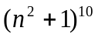 ii) 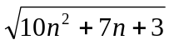 iii) 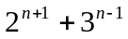 iv) 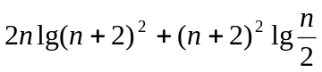 | CO1 | (08)
 | b) | If 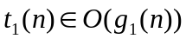 and 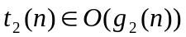, then prove that . | CO1 | (07)
 | c) | Find GCD of 31415 and 14142 by applying Euclid’s algorithm. | CO2 | (05)
2. | a) | What is time efficiency of an algorithm? Define O, Ω, and Θ asymptotic notations with one example for each. | CO1 | (07)
 | b) | Explain the general plan for analyzing non-recursive algorithm. Analyze the time efficiency of the following algorithm.  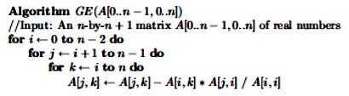 | CO1 | (08)
 | c) | Use limits for comparing orders of growth of the following functions.  i)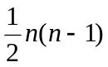 and n² ii) n! and 2^{n} | CO2 | (05)
 |  | UNIT – II
3. | a) | Apply selection sort to the following instance of an array [45,23,89,10,11,27,38].Derive the worst case time complexity of this algorithm. | CO2 | (08)
 | b) | With appropriate examples and shift tables, illustrate the four cases of shifting the search pattern in Horspool Algorithm. Write the Horspool shift table and string Matching Algorithm. | CO2 | (12)
4. | a) | Discuss how Quick sort works to sort an array? Write an algorithm for Quick sort and trace for the following data set ‘E’.’X’,’A’,’M’,’P’,’L’,’E’. | CO2 | (10)
 | b) | To which category of algorithm design technique does ‘Merge sort ‘belong? Justify your answer. | CO1 | (04)
 | c) | Define Master’s theorem .Find the order of growth of the following recursive functions using master’s theorem.  i)T(n)=4 T(n/2)+n²,T(1)=1 ii) T(n)=8 T(n/2)+n³,T(1)=1 | CO1 | (06)
 |  | UNIT – III
5. | a) | The online shop wants to display the features of its n products on its site. The space provided for display is ‘W’ which is limited. Each feature occupies certain space ‘w_{i}’ and has got a value v_{i}. The problem is to display the subset of features that are most important and can be accommodated in the given space. Design the bottom-up dynamic programming algorithm for solving this problem (choosing optimal subset to maximize total value). Analyze its i) time efficiency ii) Space efficiency iii) Time required to find the composition of an optimal subset. | CO1 | (10)
 | b) | A transportation network for 5 cities is given below along with the distance between the cities. Write the Floyd’s algorithm and apply the same to find the shortest path between all cities. (All pairs shortest path).  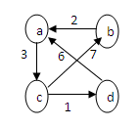 | CO2 | (10)
6. | a) | Explain the requirements to be satisfied by a greedy choice. Write Prim’s algorithm based on greedy technique to find a minimum spanning tree of the graph. Analyze its time complexity. | CO1 | (10)
 | b) | A message consisting of the characters given in the table below has to be transmitted over a network in a secured manner.  - Construct Huffman tree for the given characters (Branch label:  left(0), right(1).  - Derive Huffman codes for the given characters.  - Encode the text RAMA_RAMAR using Huffman codes.  - Decode the text whose encoding is 1000101.  - Compute the effectiveness of Huffman Codes. | CO2 | (10)
  Character | A | M | R | _
  Probability | 0.4 | 0.2 | 0.3 | 0.1
 |  | UNIT – IV
7. | a) | Find the topological ordering, using DFS and source removal methods of the graph shown below.  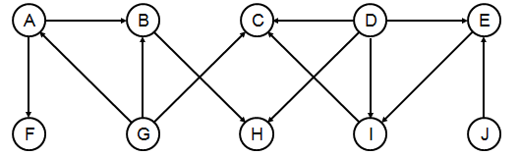 | CO4 | (10)
 | b) | Construct an AVL tree and 2-3 tree by successive insertion of the elements [5,6,8,3,2,4,7]. | CO4 | (10)
8. | a) | Design an algorithm for breadth-First-search (BFS) graph traversal.  Apply the same for the graph given below.  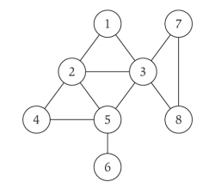 | CO4 | (10)
 | b) | Explain ‘Josephus problem’ in the context of Decrease by a constant factor technique and Find J(40)–the solution to the Josephus problem for n = 40. | CO4 | (10)
 |  | UNIT – V
9. | a) | Discuss the limitations of branch and bound technique. | CO1 | (05)
 | b) | Define and discuss the properties of heap. Design an algorithm to sort a given list of elements using heap sort incorporating transform and conquer technique. | CO1 | (10)
 | c) | Explain how backtracking can be used to solve 4-Queens problem. | CO2 | (05)
10. | a) | Define P, NP, NP-complete problems. How NP-Complete is proved? Explain. | CO3 | (10)
 | b) | Obtain the optimal tour for the travelling sales person problem of the cost matrix given below: | CO3 | (10)
   | 1 2 3 4 5
  1  2  3  4  5 | ∞ 20 30 10 11  15 ∞ 16 4 2  3 5 ∞ 2 4  19 6 18 ∞ 3  16 4 7 16 ∞
*********************

